**Performance Test Report**

**For**

**Execution of**

**Kernel Audit Manager – 205 users**

Date: 09 June 2020

Author: Gaurav Sharan

**Summary**

This report presents the observations and findings of the load test conducted for a load of 205 users on kernel audit manager service.

The objective of this load test was to observe and record behavior of the application when user load is increased from 100 to 205.

Below are the scenario details:

|  |  |
| --- | --- |
| **Script/Report Name** | Kernel Audit Manager Service |
| **Run Date** | 09-June-2020 |
| **Period** | 06:09:46 UTC to 07:17:53 UTC |
| **Number of concurrent users** | 100 to 205 |
| **Ramp up** | 01 user per second |
| **Run Duration** | --- |
| **Ramp down** | NA |

The transaction response times observed were as below:

|  |  |  |  |  |  |  |  |
| --- | --- | --- | --- | --- | --- | --- | --- |
| **Label** | **# Samples** | **Average(ms)** | **90% Line(ms)** | **Min(ms)** | **Max(ms)** | **Error %** | **Throughput** |
| TR_kernel_audit-service | 523947 | 955 | 2377 | 8 | 75117 | 67.57% | 128.2 |

**Performance Test Execution Details**

We have executed JMeter script for kernel audit manager service which has transactions mentioned in the above table.

Average response time of the APIs is 955 ms with error rate above 67 %, error appeared for audit request at a user load of 200 users when most of the APIs started failing with 503 error. The audit service pod has crashed at a user load of 200.

**Response Time and TPS Graph:**

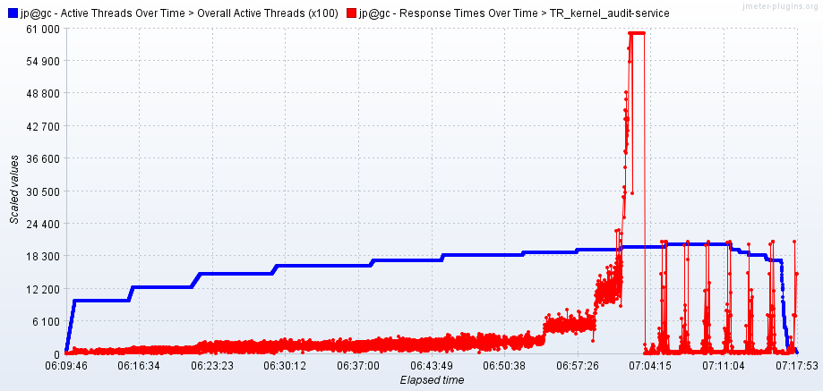

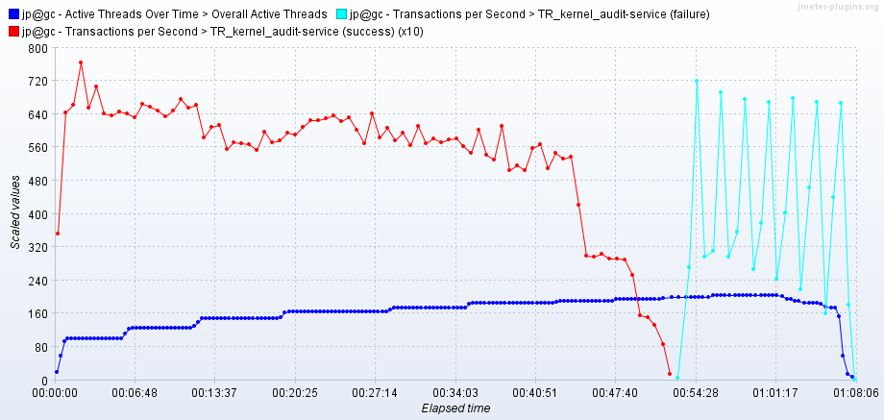

As seen in the response time graph, response time of the APIs is approx 1.3 sec when 150 users are active, it is 2.1 second for 175 users, it crosses 5 seconds for 195 users and keeps increasing and crosses 11.2 sec for 195 users. It crosses 40 second for 200 users load and crashes after some time.

Throughput (TPS) of the APIs reaches 58 when 175 users are active and comes down to 31 at 190 users level. It finally crashes at 200 user load.